

ATEX

Spreadsheet Log Method Statement

TR028 Issue 01



|  |  |  |  |  |
| --- | --- | --- | --- | --- |
| **Revision History** | | | | |
| **Issue** | **Description** | **Written** | **Approved** | **Date** |
| 01 | First Issue | Ajay Joseph |  | 28/10/20 |
|  |  |  |  |  |
|  |  |  |  |  |

***This document is the property of PSC Vodec Ltd and contains information which is strictly confidential and commercially sensitive. Disclosure of the information in this document to unauthorised third-parties is strictly forbidden.***

# Introduction

This method statement gives instruction regarding VBA application change control. This guide provides a discipline for planning and implementing change control throughout the software lifecycle. Also, to identify issues that might occur when planning to implement a change in VBA traceability log.

## Methodology

### Software change request

This has to be logged in “*Automation*” sheet in ATEX log spreadsheet. It should include date and description of what changes has to be made.

To access “Automation” sheet right click on any of the sheets/tab at the bottom of the spreadsheet and select Unhide. A pop up window will appear with options to unhide the appropriate sheet.

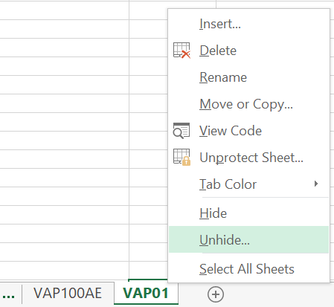

Figure 1 - Accessing automation sheet

Figure – E.g. Logging data to automation sheet

### Plan

Identify the issue and assess the complexity in order to make changes. Estimate time required to complete the process.

### Assess risk

The risk factor will depend on complexity involved with changes to be made. This can be categorised as High, Medium or Low.

Ensure to make backup of copies to preserve the data.

### Build/ Test

Save a copy externally to work with. (As required except live directory/folders). After saving a copy and following the steps below will allow developer to work on the document separately;

1. Open and disable *Autosave ()* subroutine (comment out)
   1. Developer tab, Visual Basic, Module1, *Autosave* ()
   2. 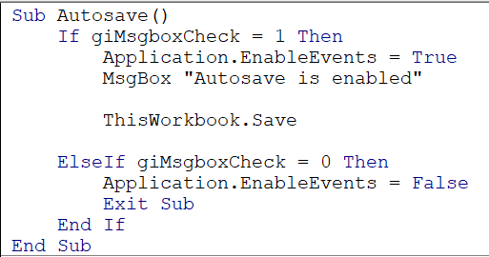
2. Change the directory in “Automation” sheet to avoid making unwanted files/folder in live directory
   1. This can be located in “Automation” sheet
   2. 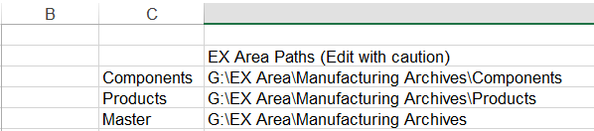
3. Identify and make necessary changes

### Implementation

* Once necessary changes have been made, make sure to receive approval to make changes to the live document.
* Ensure production is aware of the work to be carried out and notify about estimated time for completion.
* Make necessary changes to the live file without corrupting or lose of data.
* Increment the version number of the document.
* Update “*Automation*” sheet with changes made, version number and date completed.
* Enable *Autosave* () subroutine.
* Ensure the right directory is selected in “*Automation*” sheet - if this was changed previously.
* Keep track of changes from one version to another

### Release New Version

* Inform users of released version.
* Inform users of changes made.
* Inform users any associated implications.